**1] HTML**

1.1 **Basic of HTML**

1.1.1 what is HTML , use of html , about different web browser

* HTML is used to create pages
* HTML is the language in which most websites are written.
* Web browser is the application where we can run webs. Google Chrome, Microsoft Edge, Mozilla Firefox, and Safari are examples of web browsers.

1.1.2 HTML version

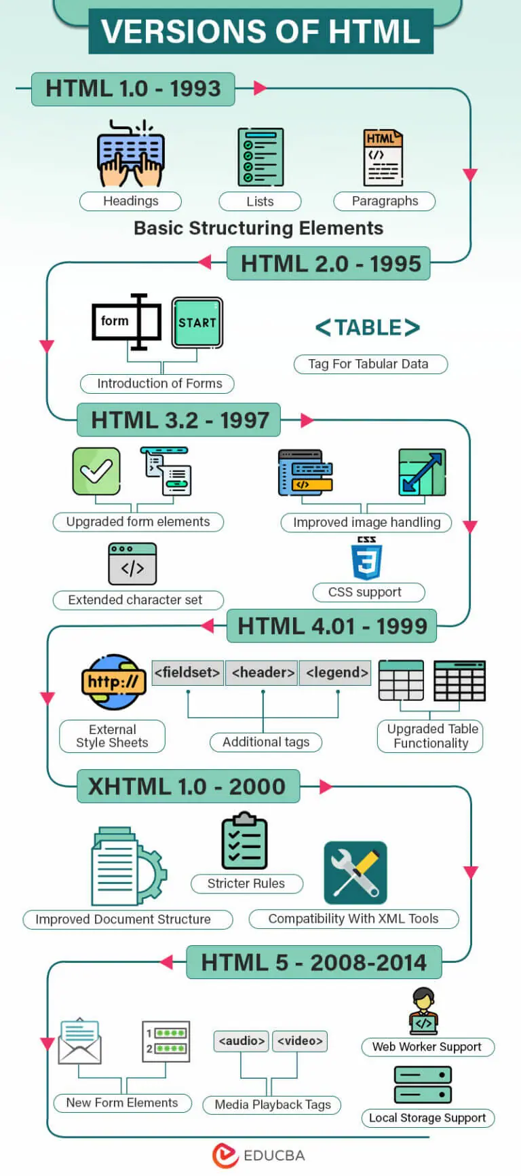

1.1.3 Structure of HTML

**<!DOCTYPE html>** // defines that this document is an HTML5 document

**<html>** // signals that from here on we are going to write in HTML code.

**<head>** // metadata for the page

**<title> </title>** // page name

**</head>**

**<body>** // content of the page

**</body>**

**</html>**

**1.2 Basic Controls**

1.2.1 form (method type, action, target, Novalidate, Autocomplete, Name)

HTML forms are use to collect various types of user input.

Action: Defines what to do after submitting form. Default action is set to current page.

EX:

<form action="/submit_result.html ">

</form>

Method : HTTP method for submitting form. Default method is get.

1. Get method : Send data using URL

Limited length (2048 characters)

Not for sensitive data like password

EX: <form action="/submit_result.html" method="get">

1. Post method : Send data inside body of HTTP request (cant be visible in URL)

No size limit

Use for sensitive data

EX: <form action="/submit_result.html" method="post">

Target : Specifies where to display response. Default target is _self .

_blank = new window or tab

_self = current window

_parent = parent frame

_top = full body of the window

framename = a named frame

EX: <form action="/submit_result.html" target="_blank">

Autocomplete : When we typing the same word it suggest from values entered before or not.

Default is on.

EX: <form action="/submit_result.html" autocomplete="off">

Novalidate : Specifies form-data should not be validated if “novalidate” presents.

EX: <form action="/submit_result.html" >

Name : Specifies name of the form.

EX: <form action="/submit_result.html" method="get" name="myForm" >

1.2.2 input

<input> element used to get various type to input from user.

The default type is “text”.

Text : single line text input.

Ex: <input type="text" id="fname" name="fname">

1.2.3 text area

Multiline input field.

Rows = number of lines

Cols = width

Ex : <textarea name="message" rows="10" cols="30">

My name is Keyur.

</textarea>

1.2.4 select box

<select> element is used to create drop-down list.

Ex: <select name="cars" id="cars">

<option value="alto">Alto</option>

<option value="city">Honda City</option>

</select>

1.2.5 checkbox

Used to select ZERO or more options.

Ex:<input type=”checkbox” id=”person1” name=”person1” value=”keyur”>

<lable for=”person1”>Keyur</lable>

<input type=”checkbox” id=”person2” name=”person2” value=”hiranj”>

<lable for=”person2”>Hiranj</lable>

1.2.6 radio button

Used to select ONLY one.

Ek:

<input type=”radio” id=”male” name=”gender” value=”male”>

<lable for=”male”>Male</lable>

<input type=”radio” id=”female” name=”gender” value=”female”>

<lable for=”female”>Female</lable>

1.2.7 button

Defines clickable button.

Ex: <input type="button" onclick="alert('Hello World!')" value="Click Me!">

1.2.8 submit input

To submit the form data to form-handler specified in “action”.

Ex: <input type="submit" value="Submit">

1.2.9 File Control with its attribute

Defines a file-select field and a “Browse” button for file uploads.

Ex: <input type="file" id="avatar" name="avatar"/>

Accept attribute used to specify file types that file input should accept.

EX: <input type="file" accept="image/*,.pdf" />

Multiple attribute specifies multiple files allows or not. (Boolean attribute)

EX: <input type="file" id="file" name="file" multiple />

**1.3 Control’s Attributes**

1.3.1 name

Specifies a Name for an HTML element.

Can be used to reference the element in a javascript.

Name in <form> : used as reference when data is submitted.

Name in <iframe> : used to target a form submission.

Name in <meta> : specifies a name for the information/value of the content attribute.

Ex:

<form action="/action_page.php">

<textarea name="comment">Enter text here...</textarea>

<input type="submit">

</form>

1.3.2 id

Specifies unique id for an HTML element. (must be unique)

Used to point a specific style declaration in a style sheet and in Javascript too.

The syntax for id is: write a hash character (#), followed by an id name. Then, define the CSS properties within curly braces {}.

Id name is case sensitive.

No whitespace and cannot start with number.

HTML bookmarks with ID and Links :

HTML bookmarks are used to allow readers to jump to specific parts of a webpage.

Bookmarks can be useful if your page is very long.

Ex:

<h2 id=”c10”> Chapter 10 </h2>

<a href=”#c10”> Jump to Chapter 10</a>

This link is bookmark for “Chapter 10”.

Note: In HTML5, id attributes can be used by any HTML tag but in HTML 4.01 there are some restriction to use id attributes. It can not be used by <head>, <html>, <meta>,<script>, <style>, and <title> tag.

1.3.3 value

To specify value (initial) of input elements like <button>, <input> and <option>.

Value in <li> : sets the value of list item.

Value in <progress> : specifies how much of the task has been completed.

Can be used with : input, meter, li, option, progress.

Ex:

<form action="/">

First name: <input type="text" name="fname" value="John"><br>

Last name: <input type="text" name="lname" value="Doe"><br>

<input type="submit" value="Submit form">

</form>

An HTML form with initial values.

<form action="/" method="get">

Choose your favorite subject:

<button name="subject" type="submit" value="fav_HTML">HTML</button>

<button name="subject" type="submit" value="fav_CSS">CSS</button>

</form>

Two buttons with equal names, that submit different values when clicked

1.3.4 class

Specifies one or more classnames for an element.

Mostly used to point class in css or javascript.

Part of the Global Attributes, and can be used on any HTML element.

Naming rules:

* Must begin with a letter A-Z or a-z
* Can be followed by: letters (A-Za-z), digits (0-9), hyphens ("-"), and underscores ("_")

EX:

HTML

<h1 class="intro important">Header 1</h1>

CSS

h1.intro {  
  color: blue;  
  text-align: center;  
}

.important {

background-color: yellow;

}

**1.4 Basic Tag with its attribute**

1.4.1 img tag, a tag

<img> : Used to embed img in HTML page.

Images are linked to web pages using <img>.

<img> tag required 2 attributes :

1. Src – path of image
2. Alt – alternate text for image

EX : <img src="man1.jpg" alt=" running man" width="500" height="600">

Width and height attributes to provide width and height to image.

<a> : Used to link pages. One to another.

Href attribute used for link’s destination.

Links will appears like :

* Unvisited = Underlined and blue
* Visited = Underlined and purple
* Actie = Underlined and red

A linked page is normally displayed in the current browser window, unless you specify another target.

Target attribute can be used with <a>.

Ex: <a href="https://www.google.com">Google!</a>

1.4.2 What is meta tag , use of meta tag

<meta> tag defines metadata about an HTML document. Metadata is data (information) about data.

Must use inside <head>

Used to specify character set, page description, keywords, author of the document, and viewport settings.

Metadata will not be displayed on the page, but is machine parsable.

Metadata is used by browsers (how to display content or reload page), search engines (keywords), and other web services.

Charset : Specifies the character encoding for the HTML document

Content : Specifies the value associated with name attribute

name : Specifies a name for the metadata

Ex: <head>

<meta charset="UTF-8">

<meta name="description" content="Demo Website"> // description of your web page

<meta name="keywords" content="HTML, CSS"> // keywords for search engines

<meta name="author" content="keyur"> // author of the page

<meta name="viewport" content="width=device-width, initial-scale=1.0"> // viewport

</head>

1.4.3 What is responsive website , how user can do it?

A responsive website is designed to adapt its layout and content to different screen sizes and devices, such as desktops, tablets, and smartphones.

We can responsive website using Viewport.

The viewport is the user's visible area of a web page.

The viewport varies with the device, and will be smaller on a mobile phone than on a computer screen.

EX: <meta name="viewport" content="width=device-width, initial-scale=1.0">

The width=device-width part sets the width of the page to follow the screen-width of the device (which will vary depending on the device).

The initial-scale=1.0 part sets the initial zoom level when the page is first loaded by the browser.